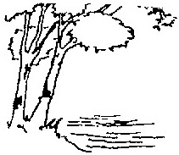

**JOINT MEETING OF THE**

**CITY COUNCIL AND THE PARKS AND NATURAL RESOURCES COMMITTEE**

**CITY OF BIRCHWOOD VILLAGE**

**WASHINGTON COUNTY, MINNESOTA**

**May 24, 2017**

**7:30 P.M.**

**CALL TO ORDER**

**APPROVE AGENDA**

**COMMITTEE BUSINESS – JOINT AGENDA**

1. Welcome New Members of the Parks Committee
2. Assignments and Expectations
3. Questions and Answers

**COMMITTEE BUSINESS – REGULAR AGENDA\***

1. Review and Discuss Committee Bylaws
2. Select Committee Officers and Meeting Times
3. Discuss and Select Next Meeting Agenda Topics

**ADJOURN**