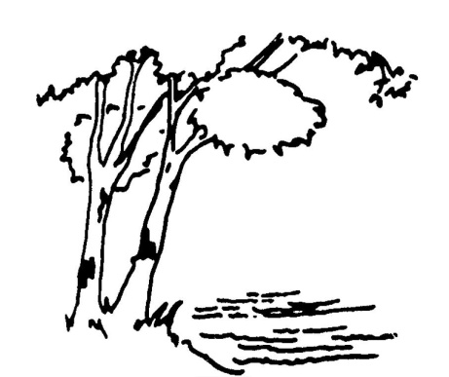

**AGENDA OF THE PARKS AND NATURAL RESOURCES COMMITTEE**

**CITY OF BIRCHWOOD VILLAGE**

**WASHINGTON COUNTY, MINNESOTA**

**April 16th, 2024**

**1:30 P.M.**

**REGULAR AGENDA**

* 1. Planning session with Lori Tella from the Washington Conservation District for the Future Public Forum on Improving Tighe-Schmitz Park on May 18 at 10AM.

**ADJOURN**