Birchwood Dock Association

***2023* Spring Meeting**

**Saturday, April 1st: 10:00 am – 11:00 am**

Hello Birchwood Neighbors!

It's time for the Dock Association Spring meeting.

All Boating and Non-Boating Members and neighbors are welcome to participate as we prepare for the 2023 boating season.

Nick Nephew, BDA President

20 Birchwood Avenue. (cell: 612-269-3492)

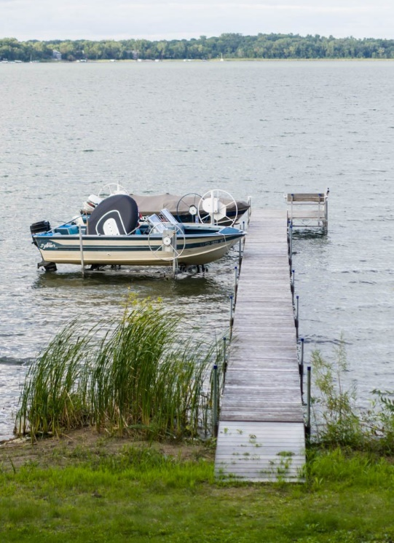



The agenda for this meeting follows:

* Call to Order
* Agenda Review
* Approve Fall Meeting Minutes
* Old business
* Treasurer’s Report
* New Business
  + Boat Slip Assignments & Commitment
  + 20 spaces committed 2023
  + Dock in date: Late April?
  + Non-returning boaters mark your lifts so they are not installed, remove by May 1
  + Identify dock managers
* Adjourn



2021 Dock Association Board of Directors:

Nick Nephew - President

Houstoun Clinch - Vice President

Alicia Jackola - Secretary

Trevor Morehead – Treasurer

Jim Berg – Member at Large

Non-boaters: Please consider becoming a voting member of the Association!

Please send this form with your **$35** **Annual** **Membership Fee**.

|  |  |  |  |  |  |  |
| --- | --- | --- | --- | --- | --- | --- |
| *First and Last Name:* | | |  | | | |
| *Address:* | |  | | | |
| *Phone Number:* |  | | | *Email:* |  |

*Please Mail:* ***Birchwood Dock Association, 20 Birchwood Avenue, Birchwood, MN 55110***