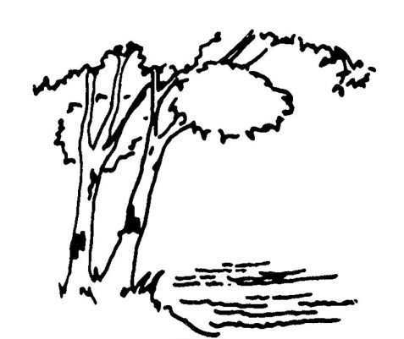

**NOTICE OF AND AGENDA FOR THE CLOSED MEETING OF THE CITY COUNCIL**

**CITY OF BIRCHWOOD VILLAGE**

**WASHINGTON COUNTY, MINNESOTA**

**January 10, 2023**

**7:15 P.M.**

**Call to Order**

**Approve Agenda**

**City Business**

1. **Closure of meeting pursuant to Minnesota Statute Chapter 13D subd. 3(b)**

**(meetings may be closed as permitted by the attorney-client privilege)**

**1. Discussion of pending civil litigation regarding claim for permit with LMCT appointed-counsel Paul Merwin, esq.**

1. **Re-open meeting**

**Adjournment**